Route Node Example

1. Click on File tab and select "New"=> "Application"

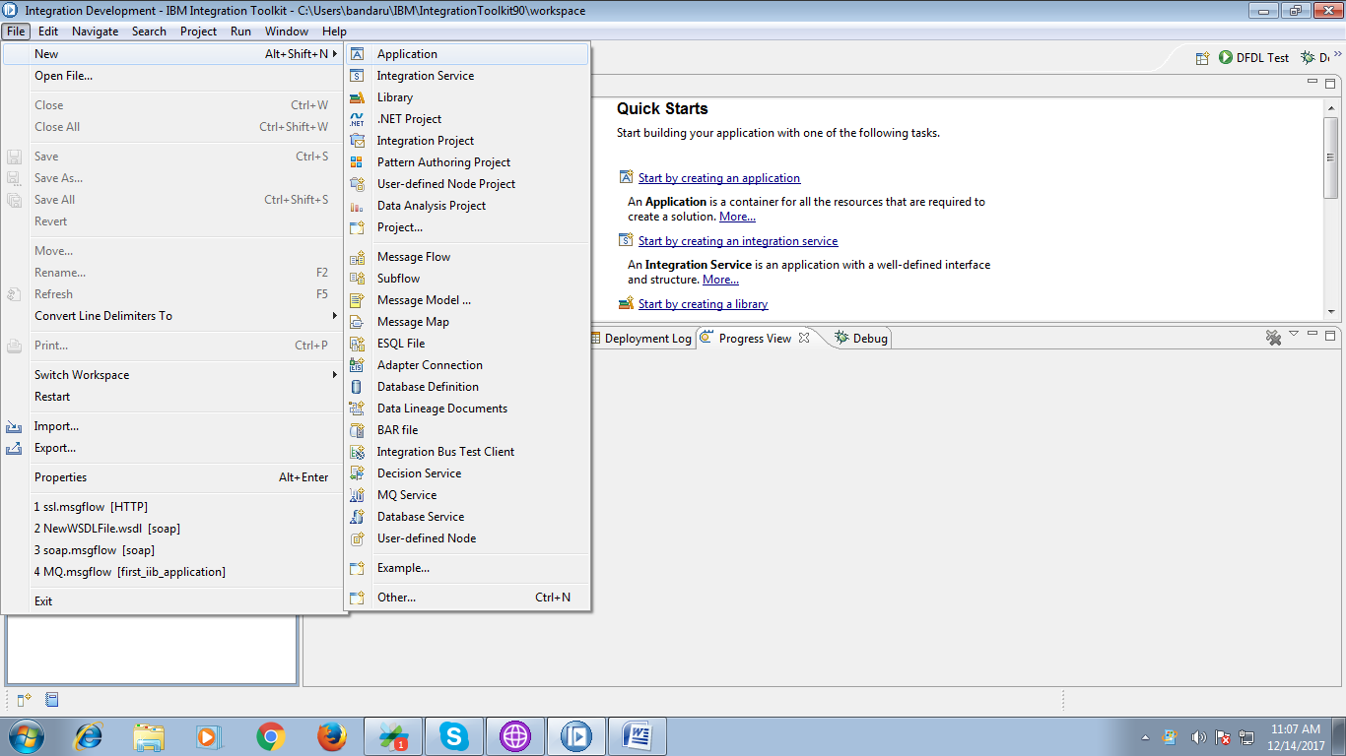

2. A pop-up will prompt asking for to give application name and hit "Finish" button.

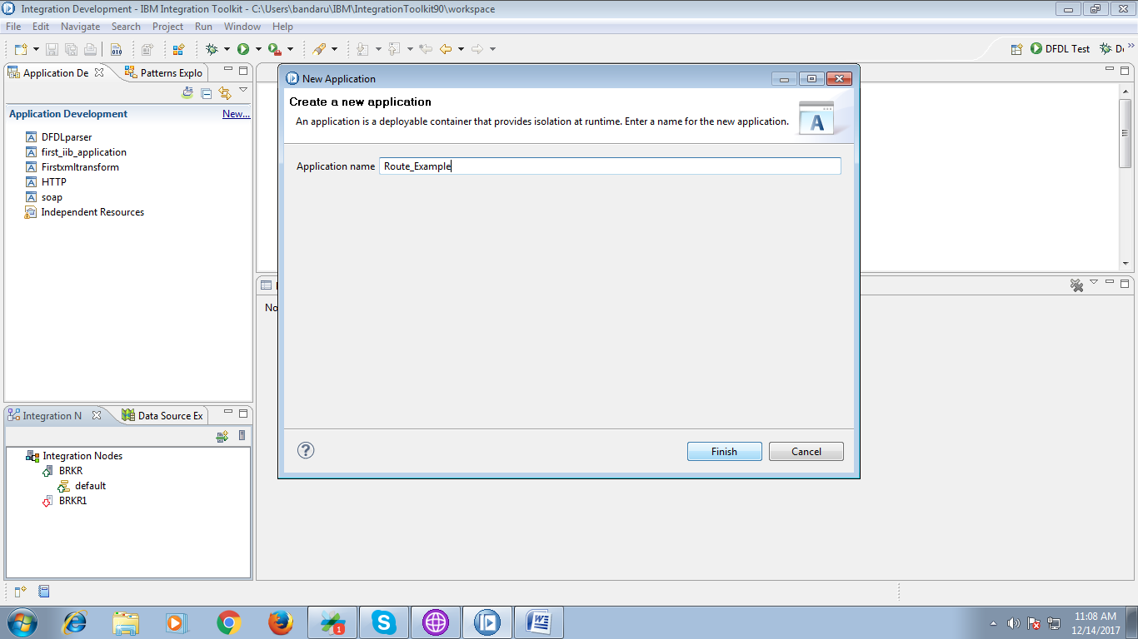

3. Under your application you can see "New" click on it.

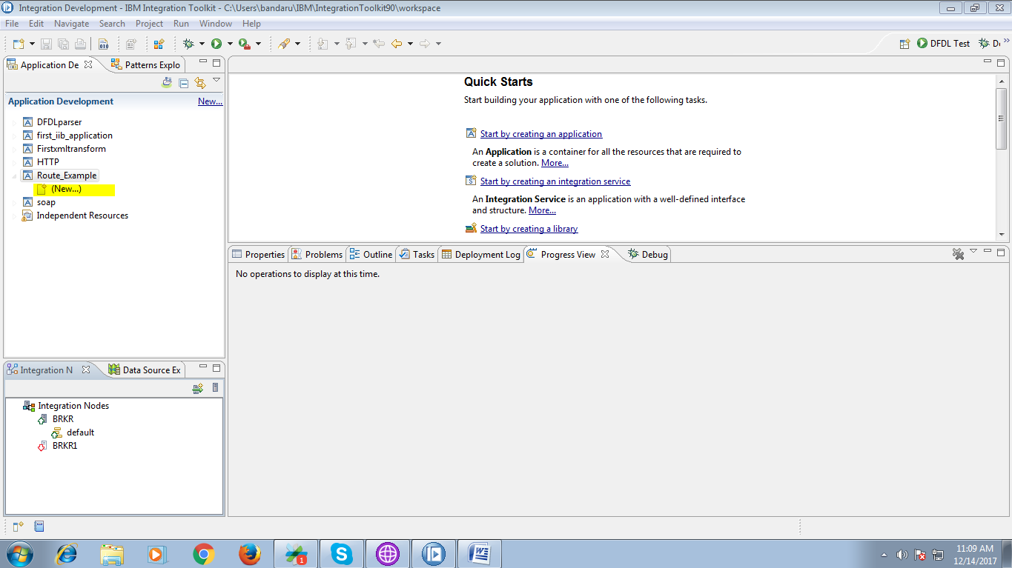

4. Select "Message Flow" from given options.

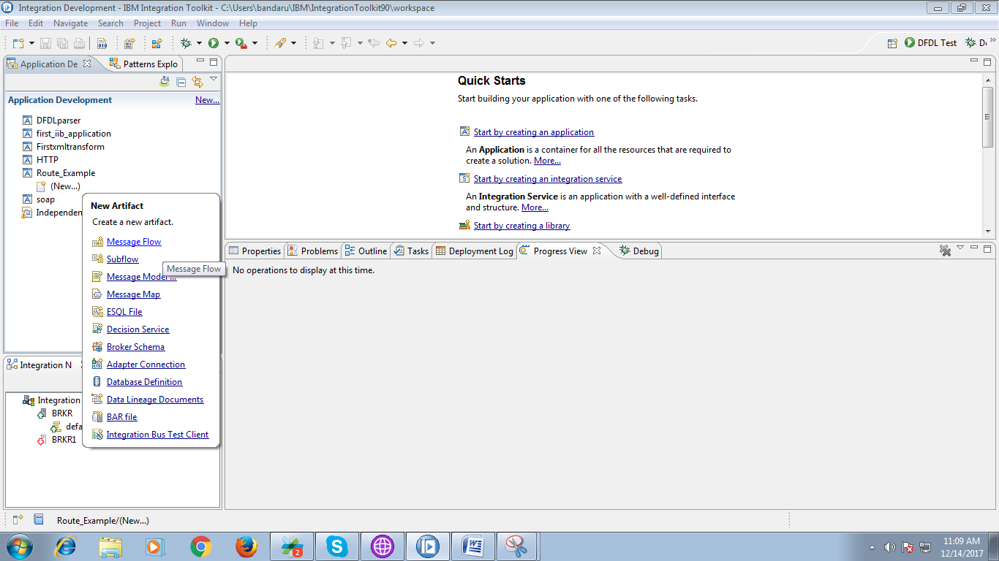

5. A pop-up will propmt asking to give flow name and hit "Finish" button.

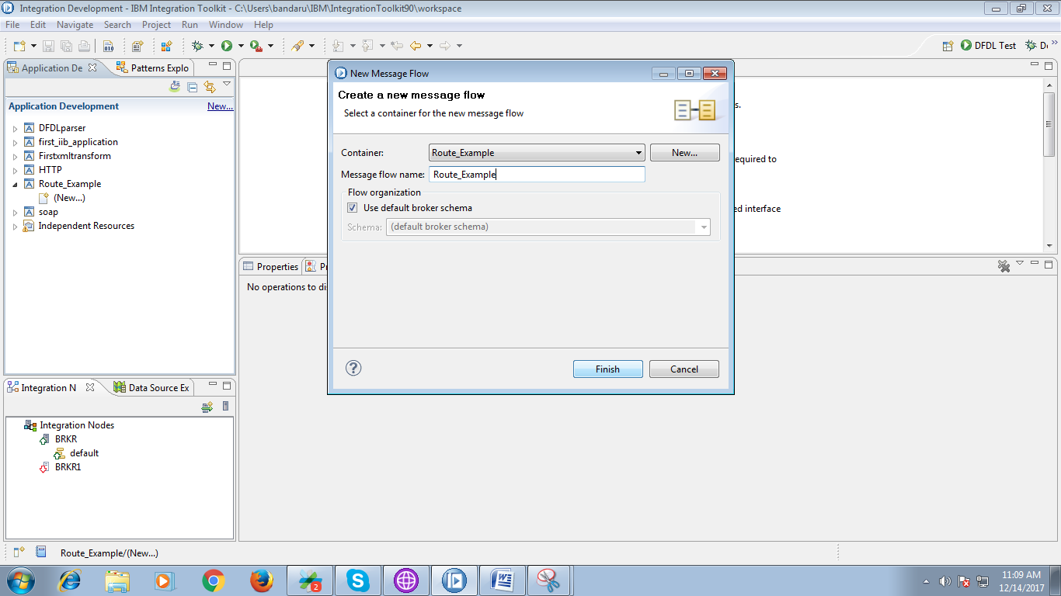

6. Drag "MQInput" from "WebSphere MQ" section and name it appropriate.

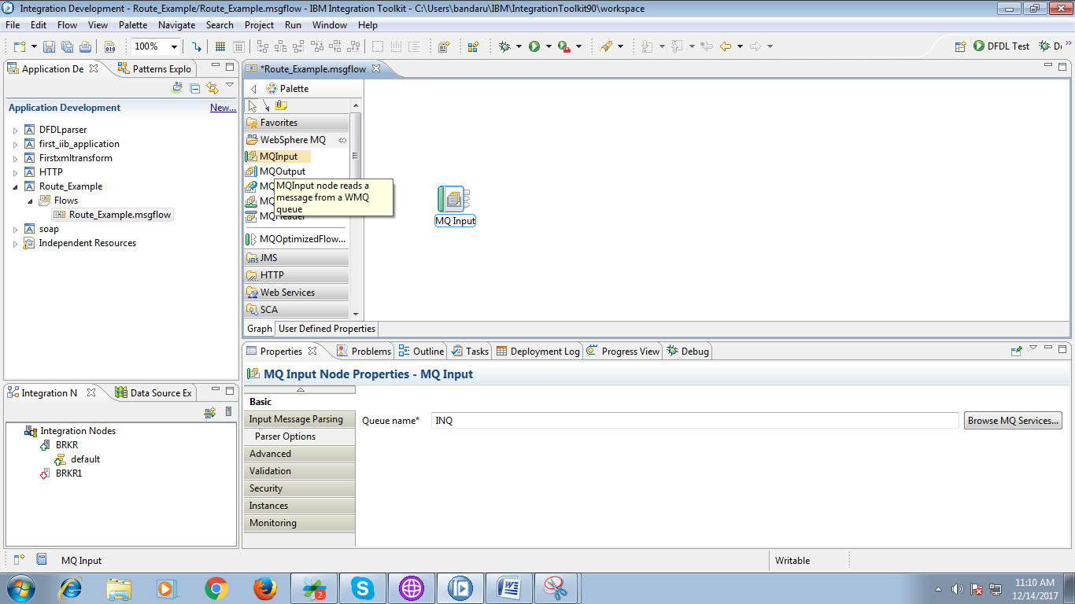

7. Under "Input Message Parsing" for the input queue select XMLNSC as messaging domain.

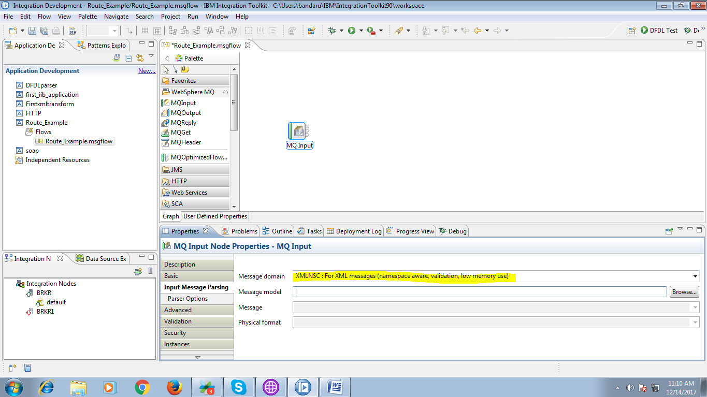

8. Drag the route node from the "Routing" section.

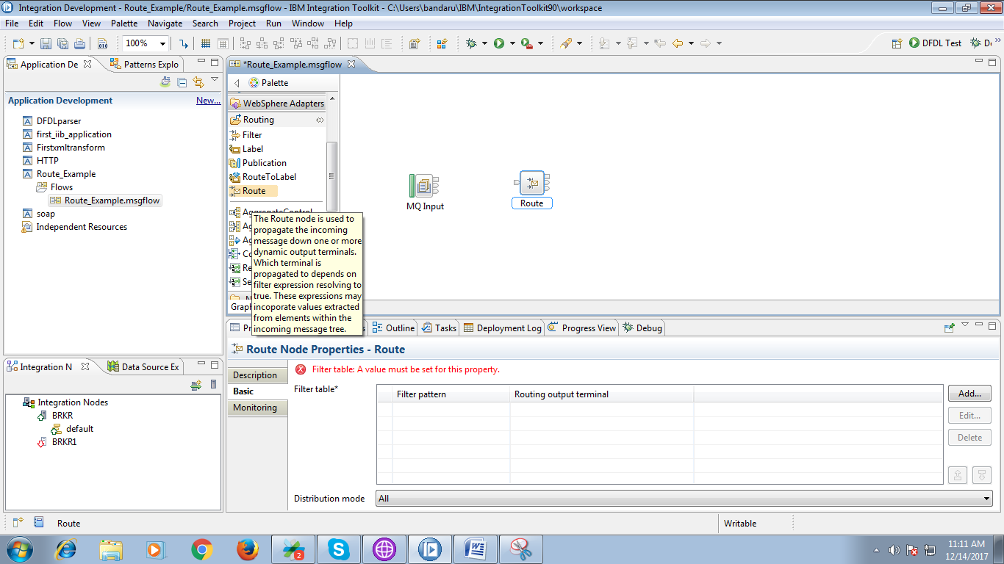

9. Drag two "MQOutput" from "WebSphere MQ" section as given fig.

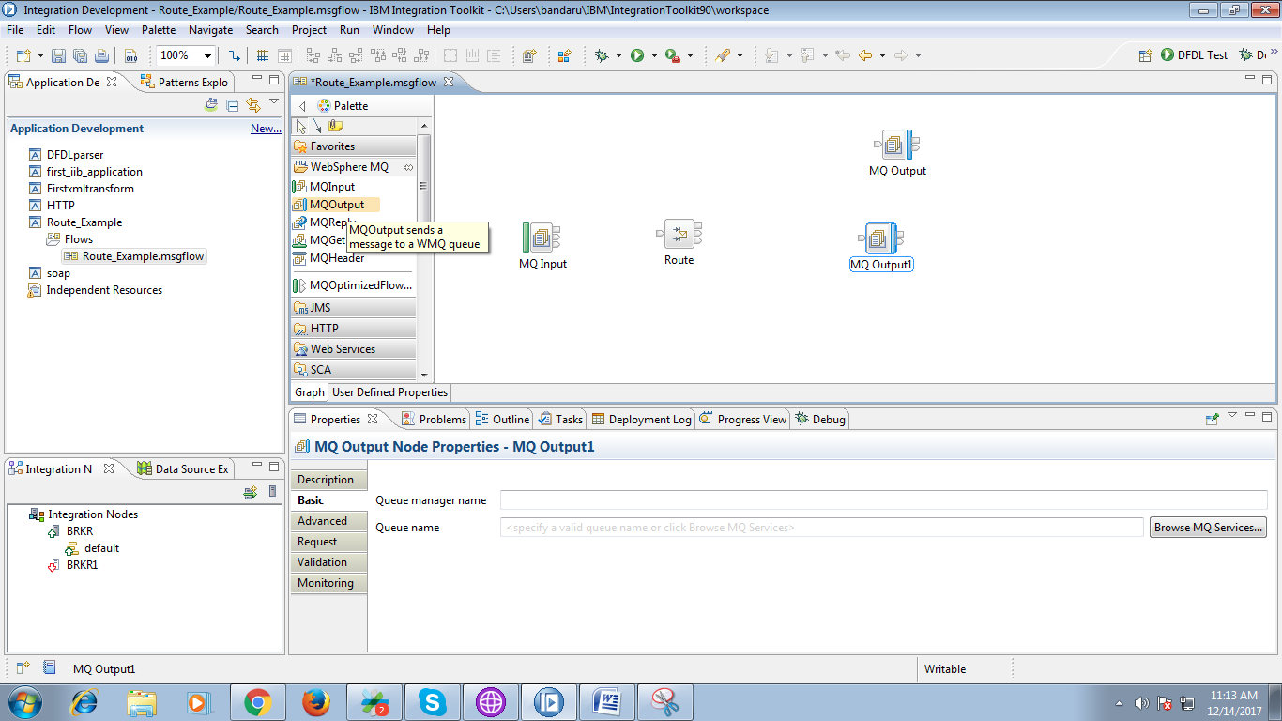

10. Name the first output queue as shown in fig.

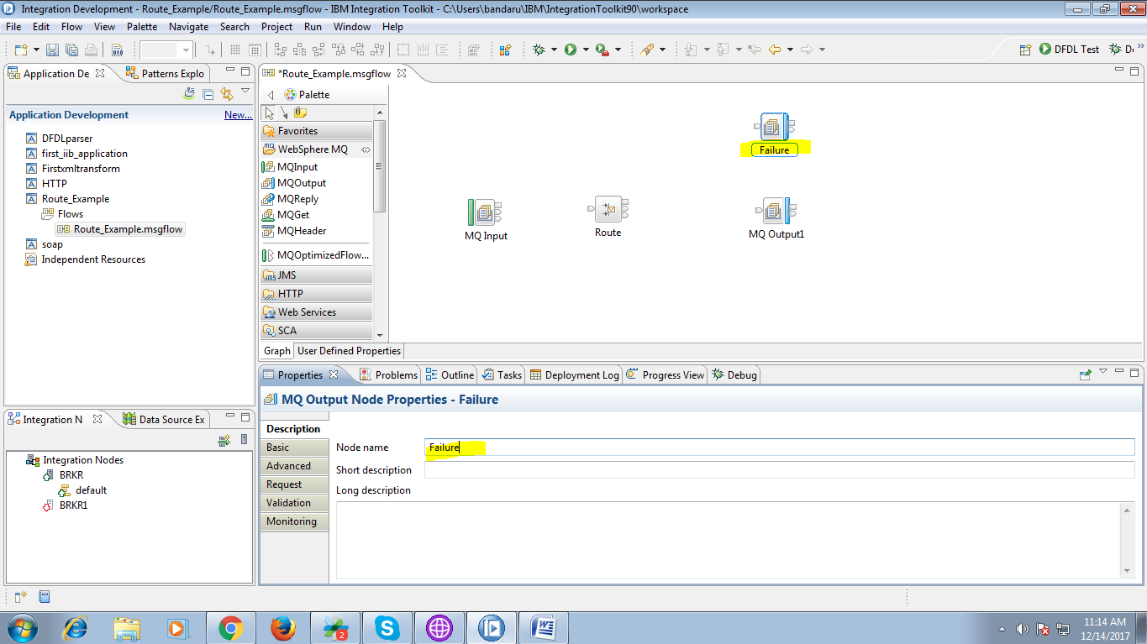

11. Name the second queue as given in below fig.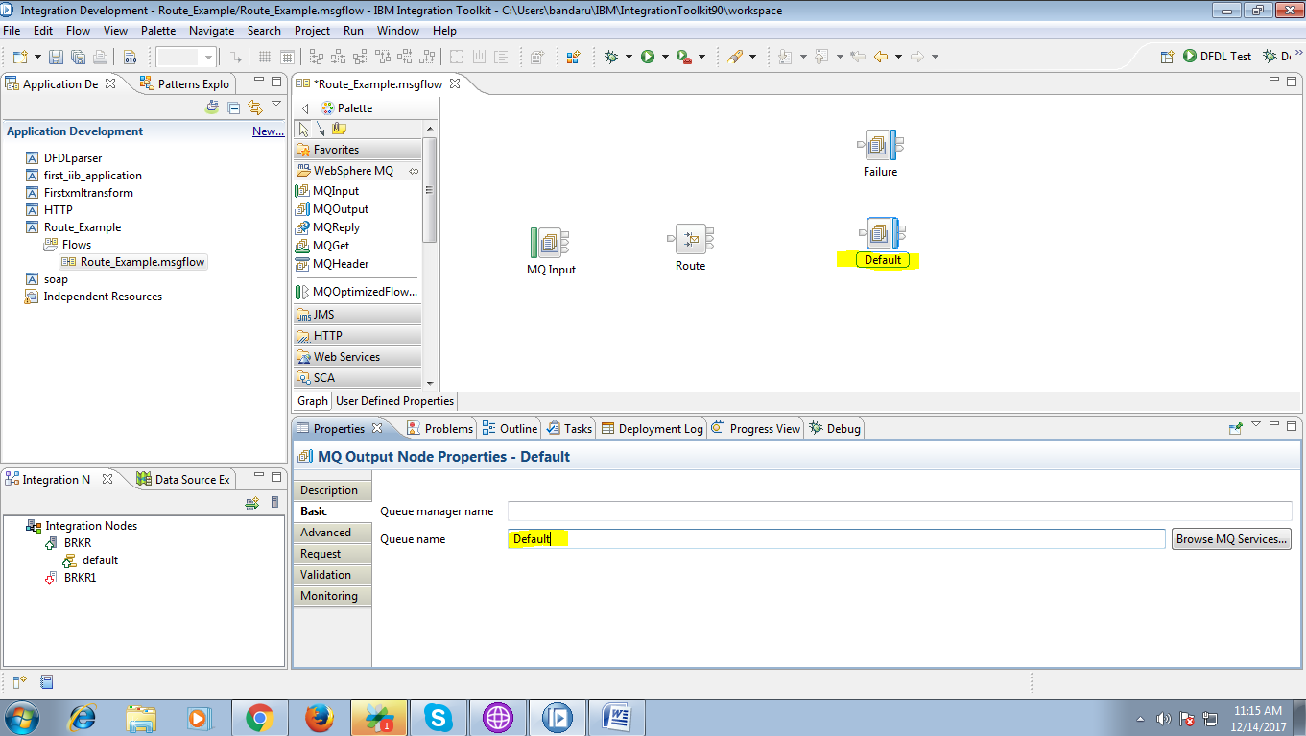

12. Drag another two "MQOutput" and name first queue among them as given below.

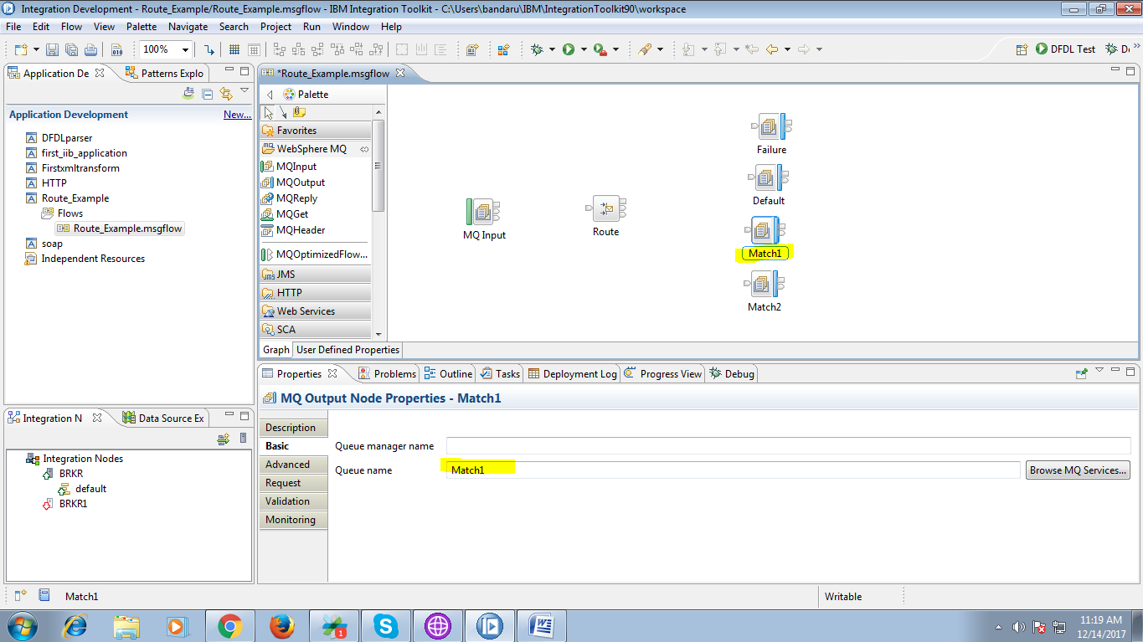

13. Name the second queue as following fig.

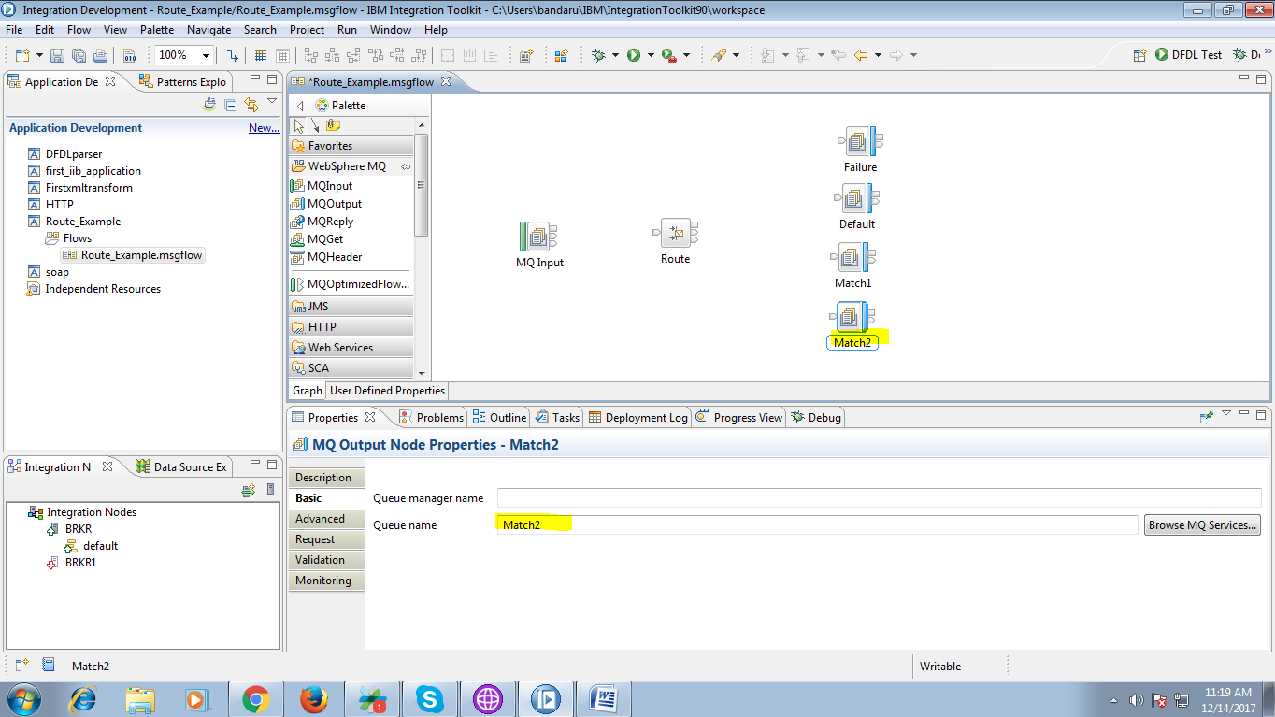

14. Connect "Failure" terminal of the route node to "input" terminal of output queue(Failure) as given below.

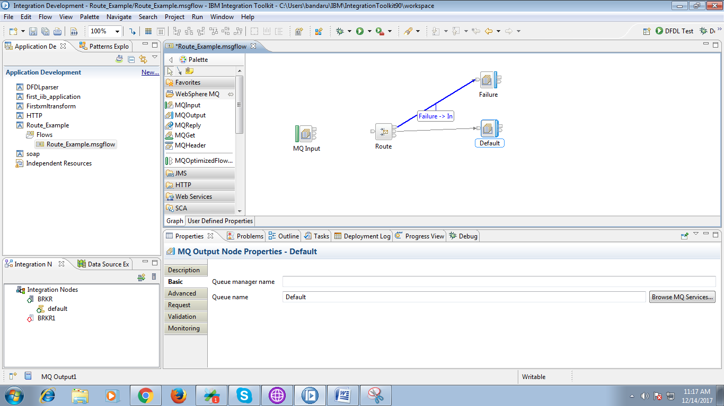

15. Connect "Default" terminal of the route node to "input" terminal of output queue(Default) as given below.

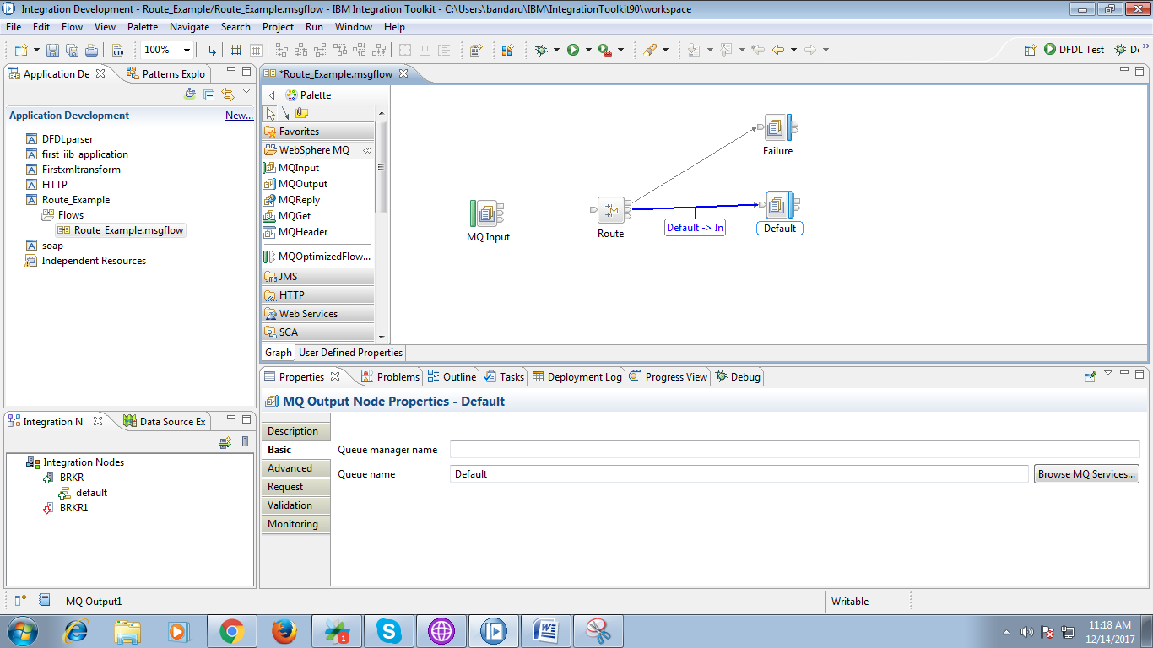

16. Connect "Match" terminal of the route node to "input" terminal of output queue(Match1) as given below.

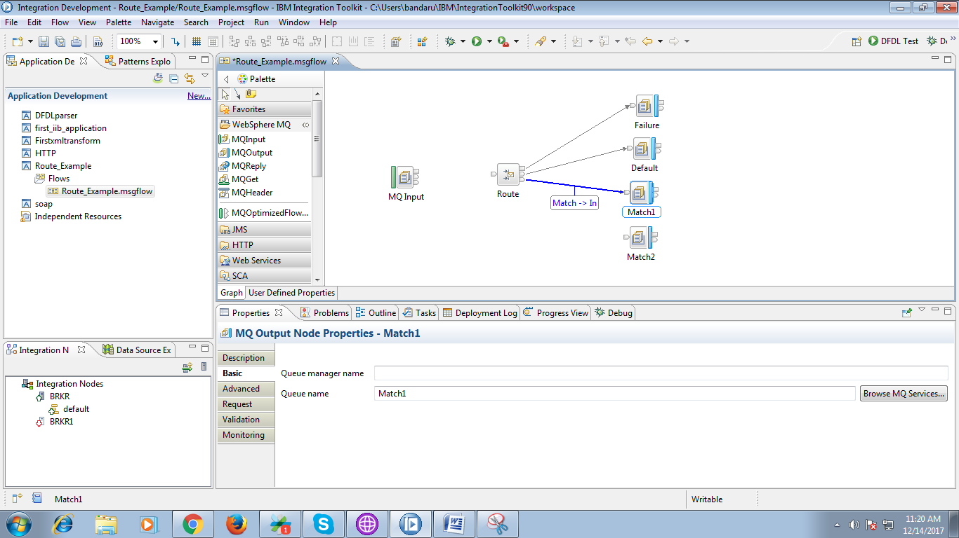

17. To create another match terminal do as following.

* Right click on route node and select "Add Output Terminal" as below fig.

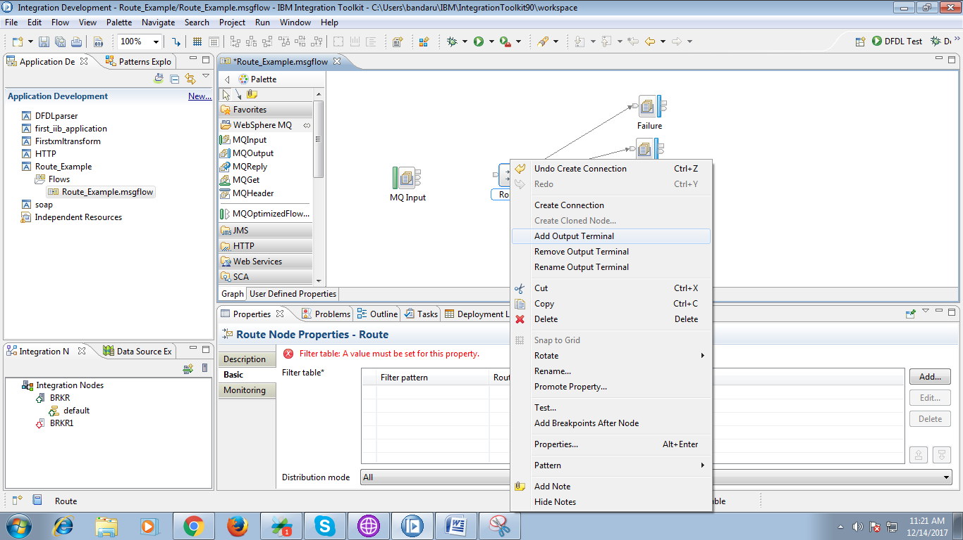

18.A pop- up will appears to name the output terminal as below fig.

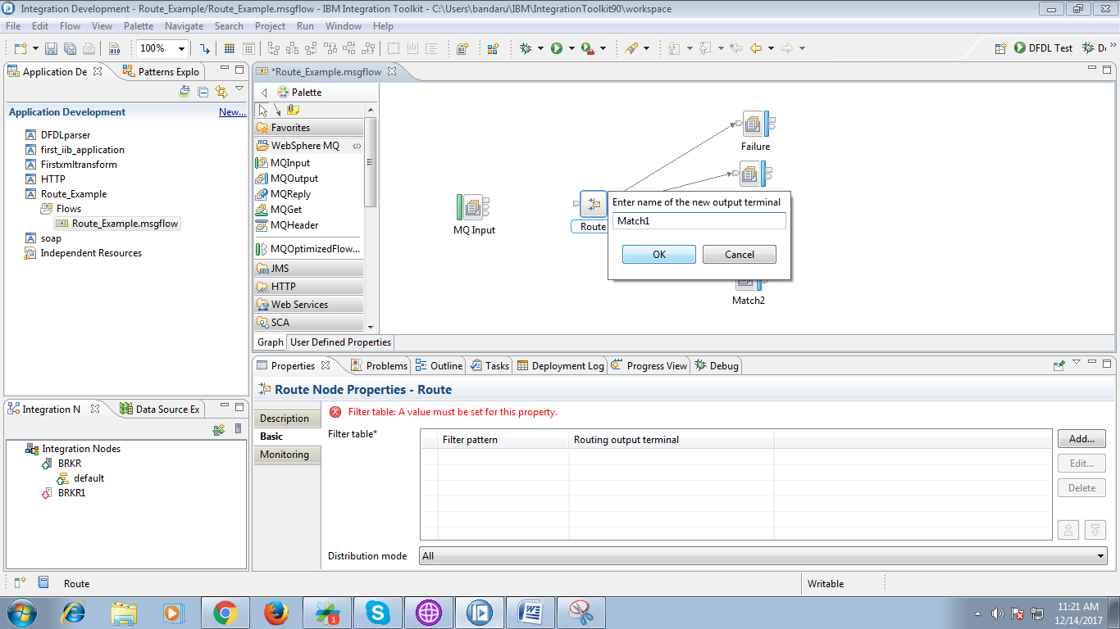

19. Now connect newly created "output" terminal of the route node to "input" terminal of output queue(Match2).

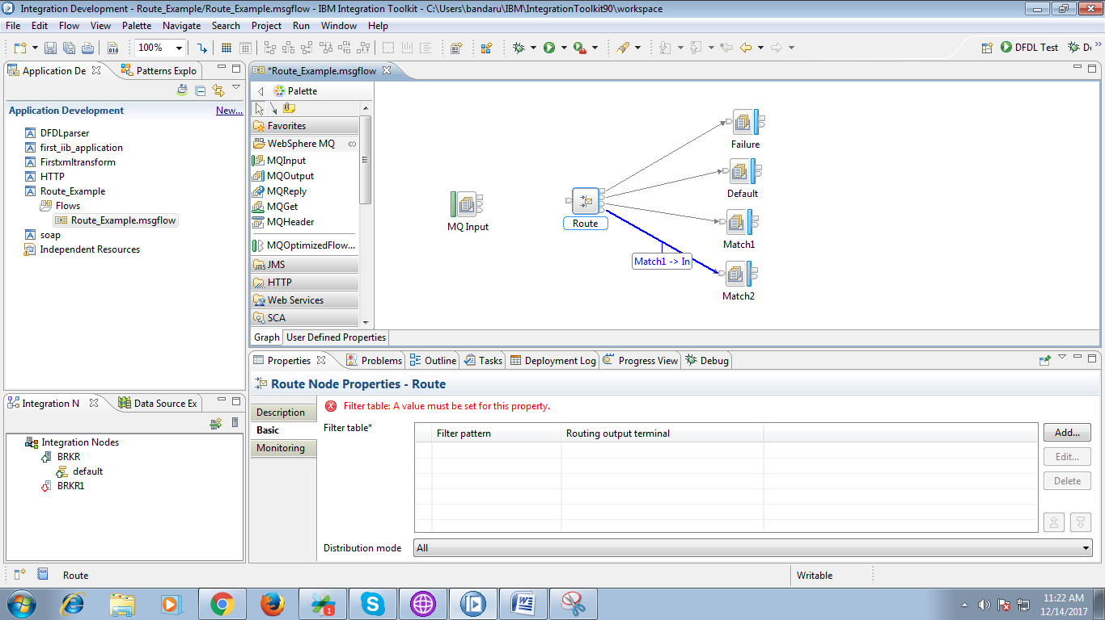

20. Now click on "Add" button on route node.

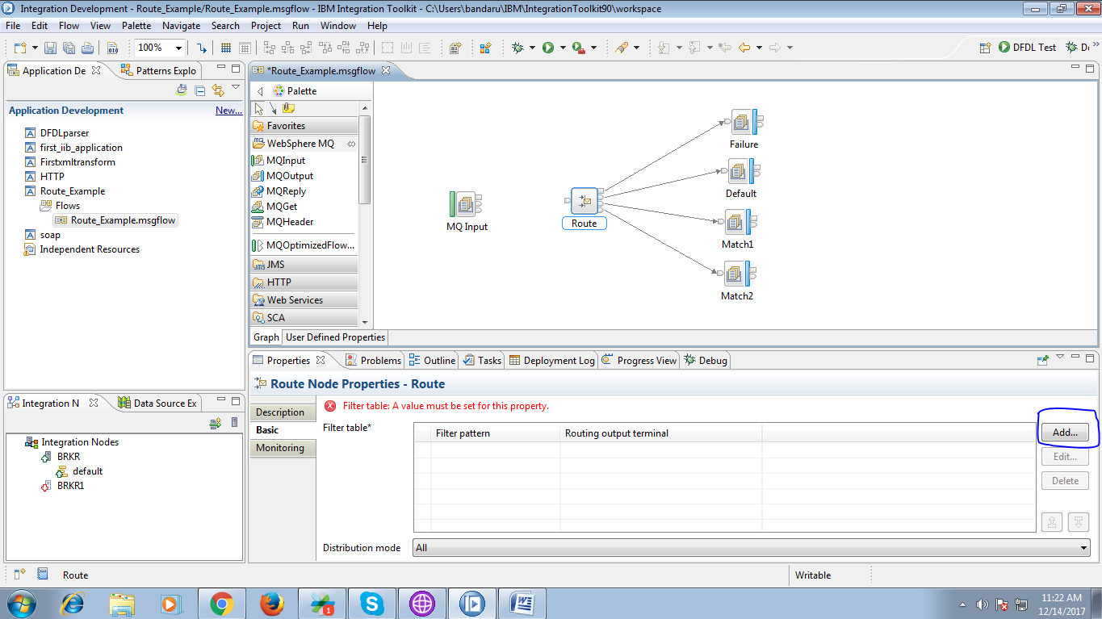

21. Provide condition in the "filter pattern" and choose respective output terminal.

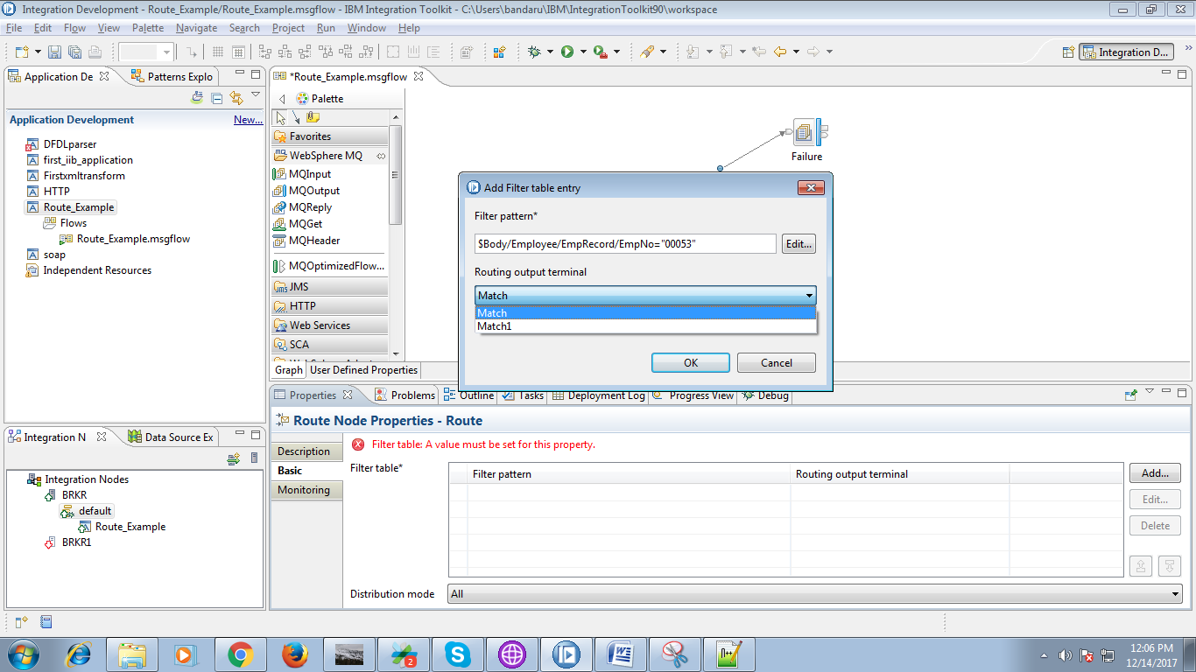

22. Provide condition in the "filter pattern" and choose respective output terminal.

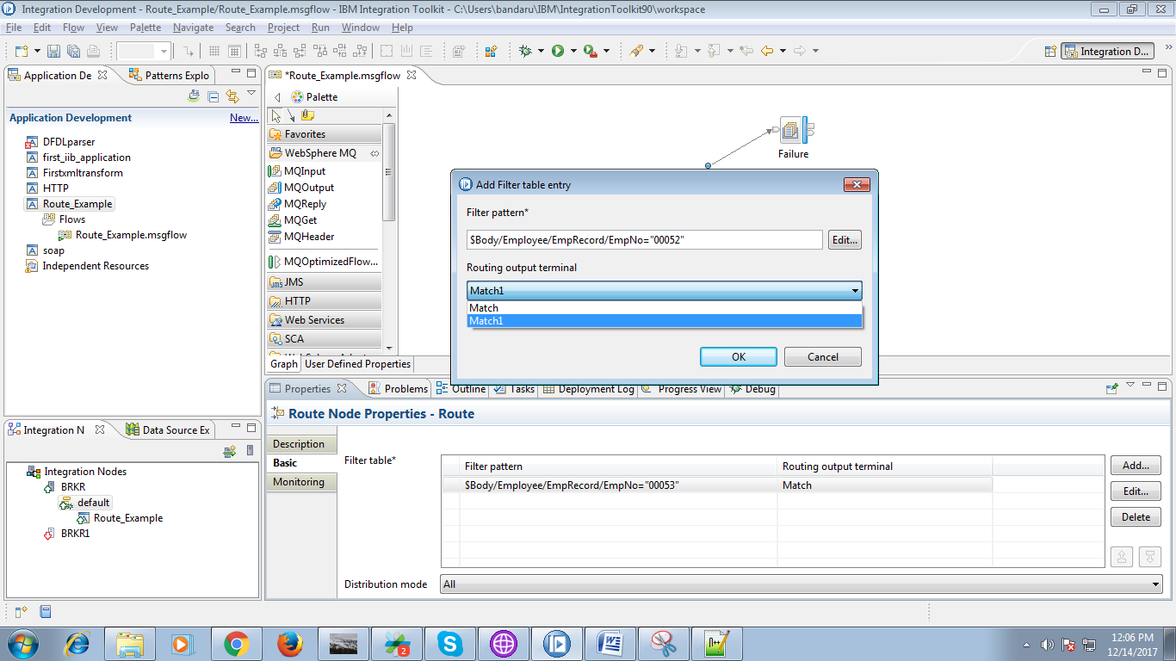

23. After matching conditions with output queues the route node looks as following.

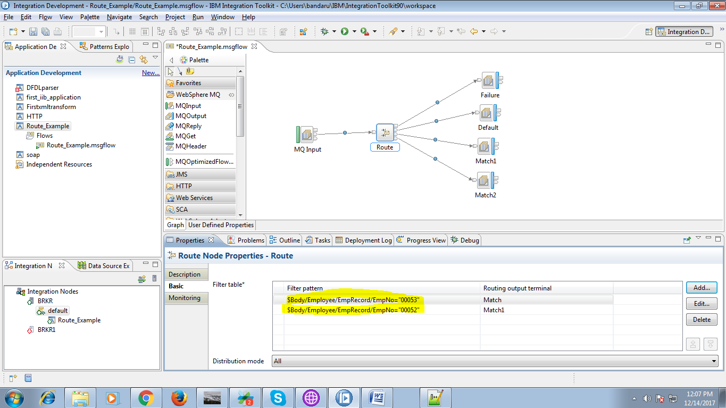

24. Connect "output" terminal of the input queue to "input" terminal of the route node.

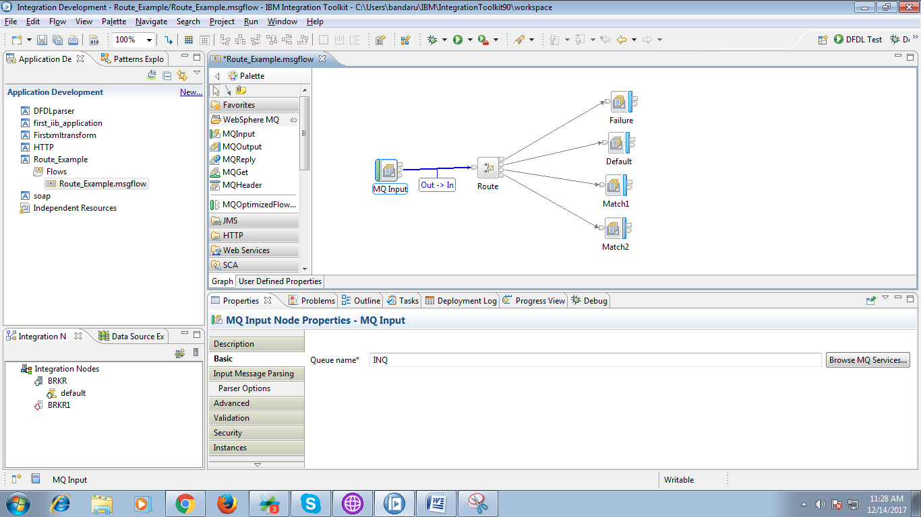

25. Now deploy the application on broker as following.

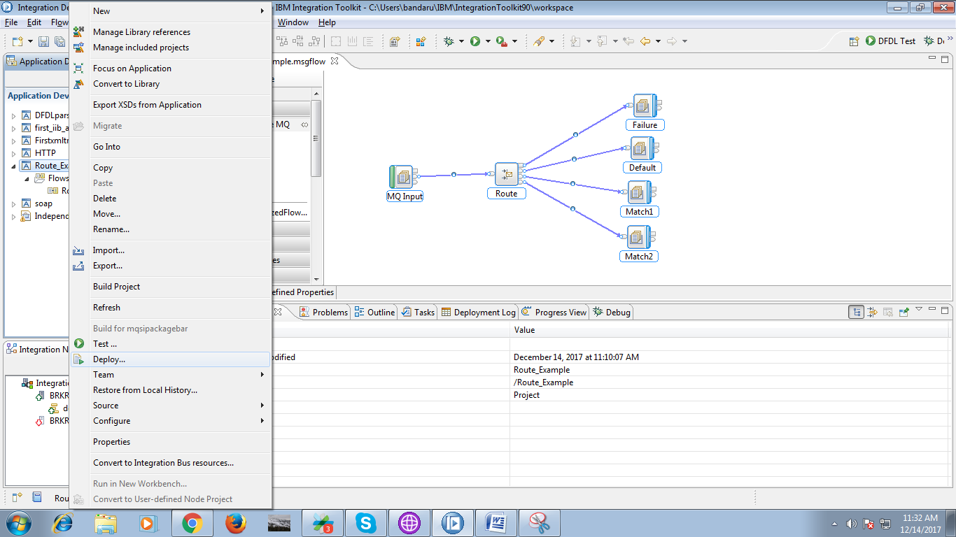

26. Create local queues in "IIB WebSphere MQ Explorer" which were defined in flow.

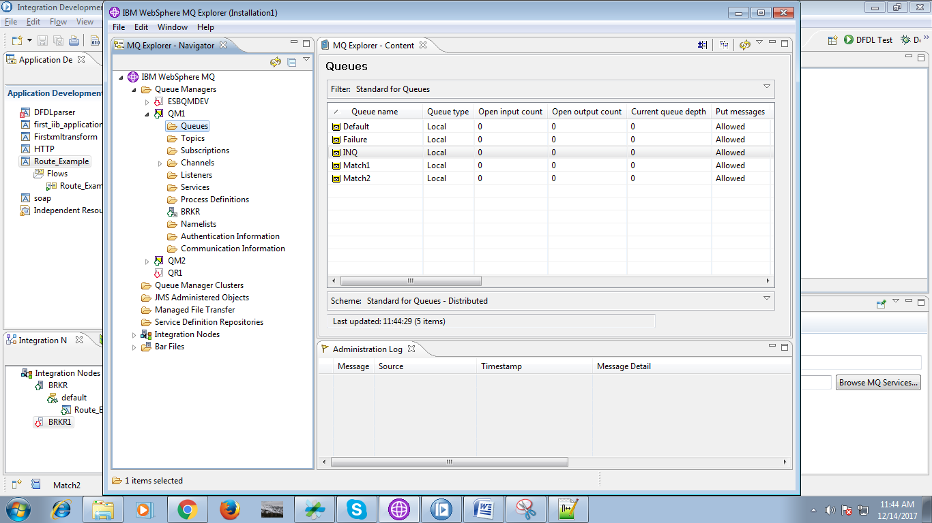

27. Input file contains following data.

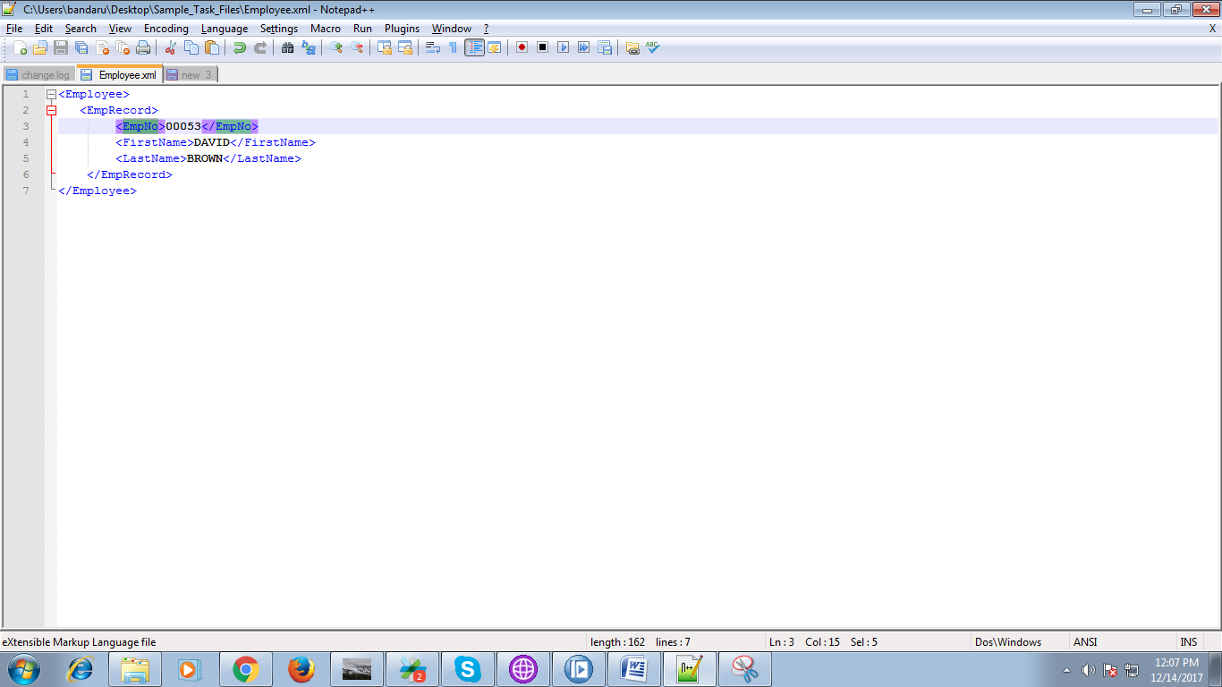

28. Select the input queue and hit "Open File" button and browse your file location.

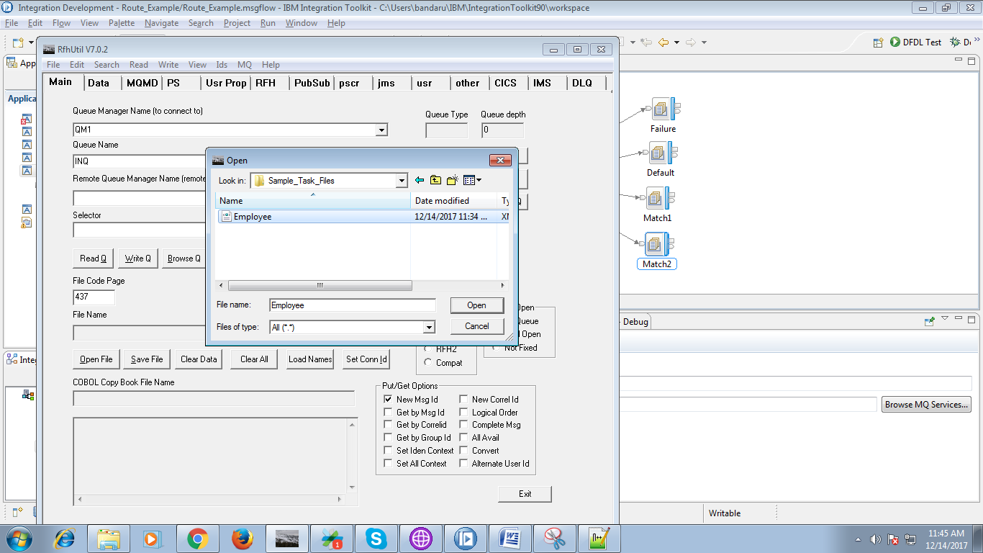

29. Your flow on debug mode.

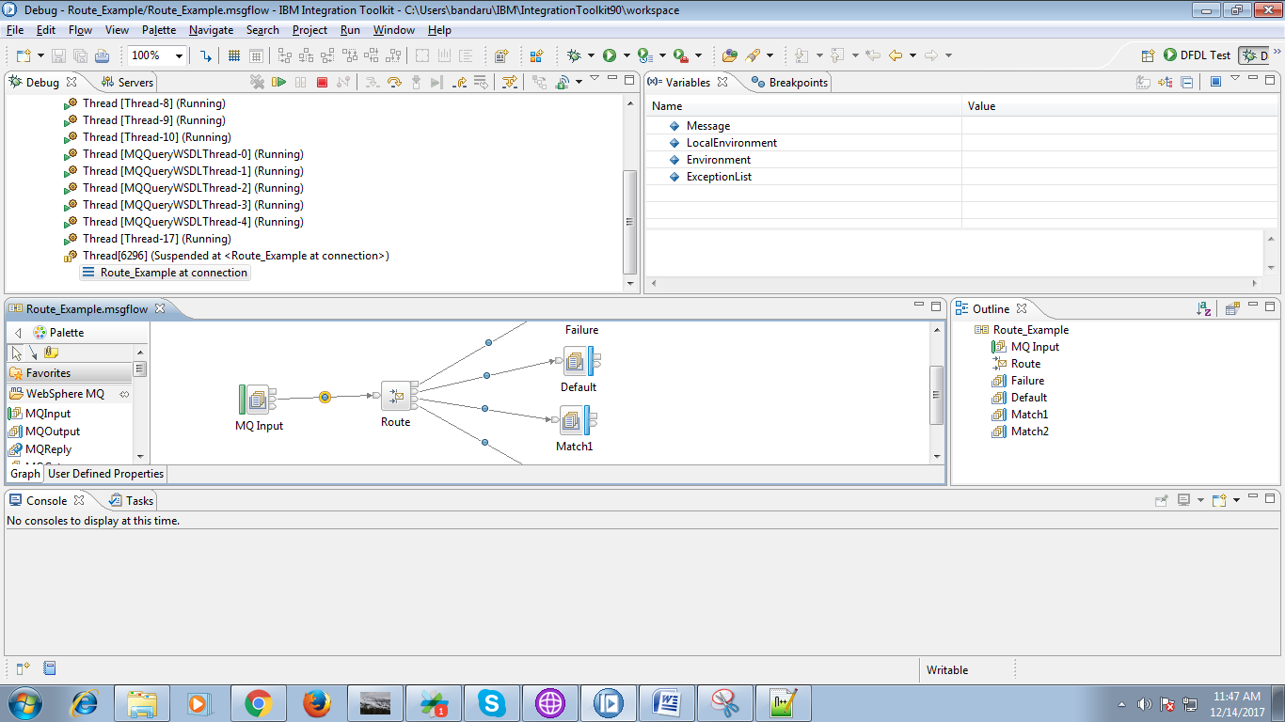

30. Route node output in debug mode.

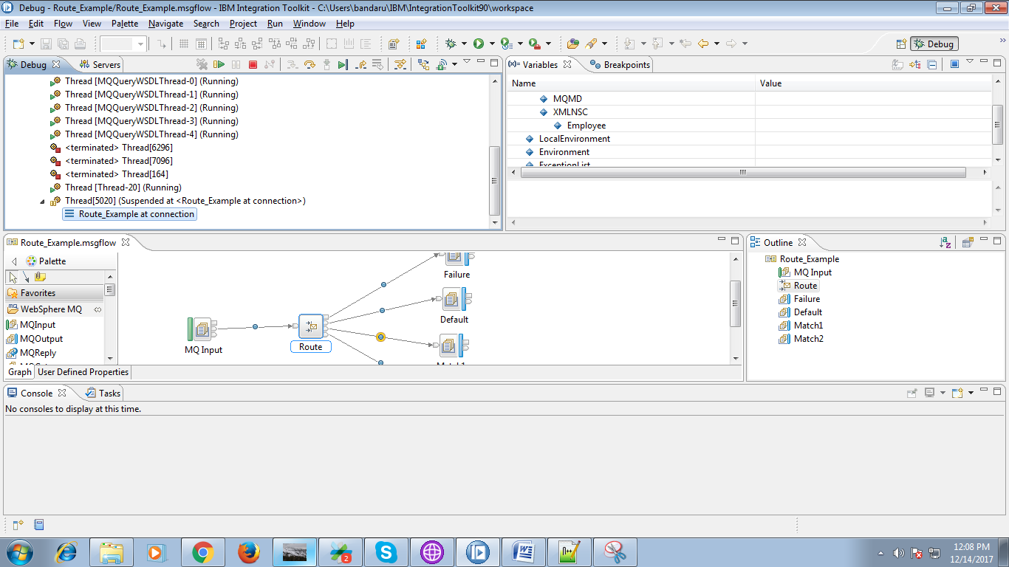

31. By selecting output queue and by hitting "Browse Q" button you can see your output queue data.

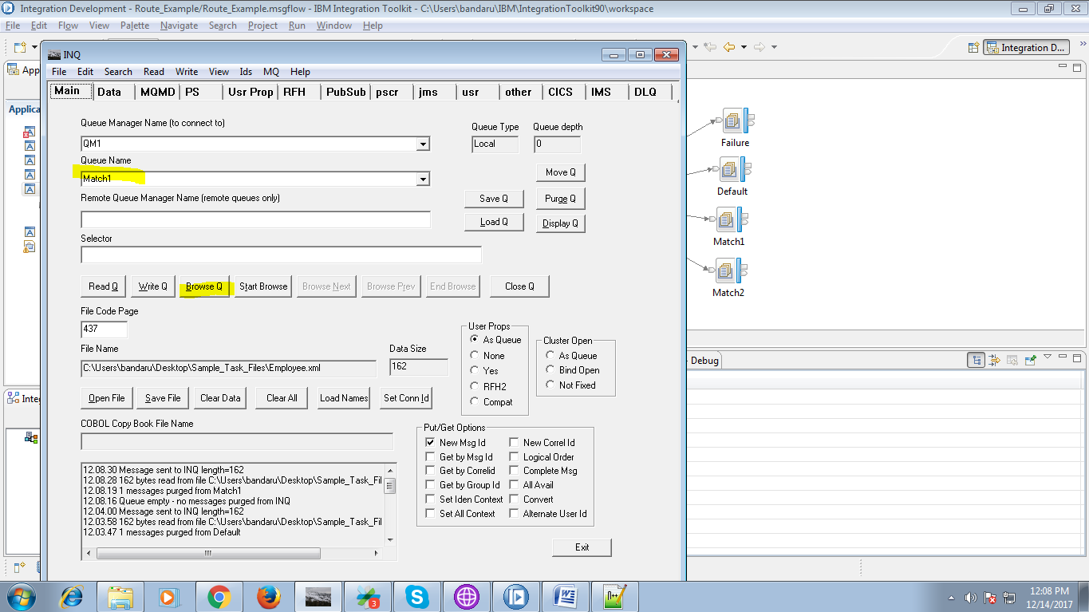

32. Output data will fing "Data" tab.

